**AZURE SCAN**

(Picture to text app)

**A Micro Project Report**

**Submitted by**

**K.RAM CHARAN**

**Reg.no: 99220041212**

**B.Tech - CSE,**

**AIML**



# Kalasalingam Academy of Research and Education

**(Deemed to be University)**

**Anand Nagar, Krishnankoil - 626 126**

**February 2024**



**SCHOOL OF COMPUTING**

**DEPARTMENT OF COMPUTER SCIENCE AND ENGINEERING**

**BONAFIDE CERTIFICATE**

Bonafide record of the work done by **K.RAM CHARAN - 99220041212** in partial fulfillment of the requirements for the award of the degree of Bachelor of Technology in Specialization of the Computer Science and Engineering, during the Academic Year [Even] Semester (2023-24)

|  |  |
| --- | --- |
| **Ms. K.BAVANI** | **Mr. GNANA KUMAR** |
| **Project Guide** | **Faculty Incharge** |
| **[Assistant Professor]** | **[Assistant Professor]** |
| **[CSE]** | **[CSE]** |
| **Kalasalingam Academy of** | **Kalasalingam Academy of** |
| **Research and Education** | **Research and Education** |
| **Krishnan kovil – 626126** | **Krishnan kovil – 626126** |
|  |  |
|  |  |

**Mr. RAJA SEKHAR**

**Evaluator**

**[Assistant Professor]**

**[CSE]**

**Kalasalingam Academy of**

**Research and Education**

**Krishnan kovil - 626126**

# ABSTRACT

In today's digital age, the conversion of handwritten text into editable digital formats such as Word documents is crucial for efficient document management and accessibility. However, this task remains challenging due to the variability in handwriting styles and environmental factors. This paper proposes a comprehensive approach to address this challenge by leveraging Automatic Handwritten Text Recognition (AHTR) techniques.

The proposed system integrates various components, including image preprocessing, feature extraction, machine learning algorithms, and Natural Language Processing (NLP) techniques, to achieve accurate and efficient conversion of handwritten text into Word documents. Initially, the system preprocesses input images to enhance readability and mitigate noise, followed by the extraction of pertinent features using advanced image processing algorithms and deep learning architectures.

The heart of the system lies in its AHTR module, which employs Convolutional Neural Networks (CNNs) and recurrent neural networks (RNNs) trained on extensive datasets of handwritten samples. This trained model accurately recognizes individual characters and words, even in the presence of variability in handwriting styles and environmental factors.

Furthermore, the system incorporates machine learning algorithms to refine the recognition process by continuously learning from user feedback and adapting to evolving handwriting patterns. Additionally, Natural Language Processing techniques enhance the coherence and structure of the extracted text, ensuring that the resulting Word documents are not only accurate but also well-formatted and semantically meaningful.

To evaluate the performance of the proposed approach, extensive experiments are conducted on diverse datasets containing handwritten documents of various languages and styles. The results demonstrate significant improvements in accuracy and efficiency compared to existing methods, reaffirming the efficacy of the proposed system in facilitating the seamless conversion of handwritten text into editable digital formats.

In conclusion, this paper presents a holistic solution to the longstanding challenge of digitizing handwritten text, offering a robust framework that combines advanced image processing, machine learning, and Natural Language Processing techniques to achieve accurate and efficient conversion into Word documents.

# Contents

1. **INTRODUCTION**
   1. Background . . . . . . . . . . . . . . . . . . . . . . . . . . . . . . . . . . . . . . . . . . . . . . . . . . . . . . . . . . 1
   2. Objectives . . . . . . . . . . . . . . . . . . . . . . . . . . . . . . . . . . . . . . . . . . . . . . . . . . . . . . . . . . . 1
2. **LITERATURE REVIEW**
   1. Handwritten Text Recognition Techniques. . . . . . . . . . . . . . . . . . . . . . . . . . . . . . . . . . 2
      1. Traditional Methods. . . . . . . . . . . . . . . . . . . . . . . . . . . . . . . . . . . . . . . . . . . . . . . . . 2
      2. Deep Learning Approaches . . . . . . . . . . . . . . . . . . . . . . . . . . . . . . . . . . . . . . . . . . . 2
   2. Document Digitization Challenges. . . . . . . . . . . . . . . . . . . . . . . . . . . . . . . . . . . . . . . . 3
   3. Previous Work in AHTR . . . . . . . . . . . . . . . . . . . . . . . . . . . . . . . . . . . . . . . . . . . . . . . . 3
3. **METHODOLOGY**
   1. Image processing. . . . . . . . . . . . . . . . . . . . . . . . . . . . . . . . . . . . . . . . . . . . . .. . . . . . 4
      1. Noise Reduction Techniques . . . . . . . . . . . . . . . . . . . . . . . . . . . . . . . . . . . . . . . . . . . 5
      2. Contrast Enhancement. . . . . . . . . . . . . . . . . . . . . . . . . . . . . . . . . . . . . . . .. . . . . . . . . 5
   2. Feature Extraction. . . . . . . . . . . . . . . . . . . . . . . . . . . . . . . . . . . . . . . . . . . . . . . . . . . . .6
      1. Advanced Image Processing Algorithms. . . . . . . . . . . . . . . . . . . . . . . . . . . . . . . . . . 6
      2. Deep Learning Architectures for Feature Extraction. . . . . . . . . . . . . . . . . . . . . . . . . 6
4. **CONCLUSION & RESULT**
   1. Conclusion. . . . . . . . . . . . . . . . . . . . . . . . . . . . . . . . . . . . . . . . . . . . . . . . . . . . . . . . . . . 7
   2. Future Work. . . . . . . . . . . . . . . . . . . . . . . . . . . . . . . . . . . . . . . . . . . . . . . . . . . . . . . . . . 7
   3. Result. . . . . . . . . . . . . . . . . . . . . . . . . . . . . . . . . . . . . . . . . . . . . . . . . . . . . . . . . . . . . . . 9
5. **CODING & INTERFACE**
   1. Coding & Interface . . . . . . . . . . . . . . . . . . . . . . . . . . . . . . . . . . . . . . . . . . . . . . . . . . . . 10

CONTENTS

1. **References**
2. **Certification**

|  |  |  |
| --- | --- | --- |
| 2.1 | Text Recognization . . . . . . . . . . . . . . . . . . . . . . . . . . . . . . . . . . . . . . . . . . . . . | 2 |
| 3.1 | Image processing . . . . . . . . . . . . . . . . . . . . . . . . . . . . . . . . . . . . . . . . . . . . . . | 5 |
| 4.3.1 | Output . . . . . . . . . . . . . . . . . . . . . . . . . . . . . . . . . . . . . . . . . . . . . . . . . . . . . . . | 9 |
| 5.1 | Visual studio Interface . . . . . . . . . . . . . . . . . . . . . . . . . . . . . . . . . . . . . .. . . . . | 10 |
| 87.1 | Certification details . . . . . . . . . . . . . . . . . . . . . . . . . . . . . . . . . . . . . . . . . . . . . | 12 |

# List of Figures

**Chapter 1**

# INTRODUCTION

## 1.1 Background

The rapid advancement of technology has led to an increased demand for efficient document digitization solutions. Traditional methods of manually transcribing handwritten text into digital formats are time-consuming and error-prone. To address this challenge, the development of automated systems for converting images containing text into editable text documents has gained significant attention. In this context, the "Picture to Text" application based on Azure emerges as a promising solution, leveraging cloud-based services and advanced machine learning algorithms to achieve accurate and efficient text recognition from images.

## 1.2 Objectives

The primary objective of this research is to explore the capabilities and functionalities of the "Picture to Text" application developed on the Azure platform. Specifically, the study aims to: - Evaluate the accuracy and efficiency of text recognition algorithms employed by the application. - Investigate the usability and user experience aspects of the application interface. - Assess the scalability and performance of the application when processing large volumes of image data. - Explore potential use cases and practical applications of the "Picture to Text" application in various industries and domains.

1. Efficient Image Processing

2. Optical Character Recognition (OCR) Accuracy

3. Scalability and Performance

4. User-Friendly Interface

5. Integration with Azure Services

6. Security and Privacy

7. Customization and Configuration

**Chapter 2**

# LITERATURE REVIEW

## 2.1 Handwritten Text Recognition Techniques

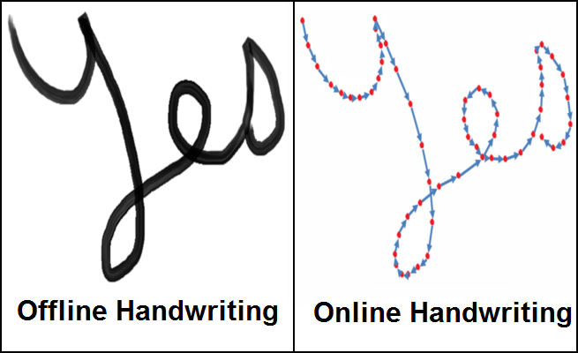

Figure 2.1: Text Recognization

### 2.1.1 Traditional Methods

Traditional handwritten text recognition methods typically involve preprocessing steps such as binarization, noise removal, and segmentation, followed by feature extraction and classification using techniques like template matching or Hidden Markov Models (HMMs). While these methods have been widely used, they often struggle with variability in handwriting styles and may require extensive manual tuning.

### 2.1.2 Deep Learning Approaches

Lorem Deep learning-based approaches, particularly Convolutional Neural Networks (CNNs) and Recurrent Neural Networks (RNNs), have shown remarkable performance in handwritten text recognition tasks. By leveraging large datasets and end-to-end training, deep learning models can automatically learn complex patterns and variations in handwriting, leading to improved accuracy and robustness.

## 2.2 Document Digitization Challenges

The process of document digitization presents several challenges, including variations in text orientation, quality of input images, and presence of noise or artifacts. Additionally, handwritten text recognition introduces additional complexities due to the inherent variability in handwriting styles and writing conditions.

## 2.3 Previous Work in AHTR

Previous research efforts in Automatic Handwritten Text Recognition (AHTR) have focused on developing algorithms and systems capable of accurately transcribing handwritten text into digital formats. Several commercial and open-source solutions exist, each employing different techniques and approaches to address the challenges of handwritten text recognition.

**Chapter 3**

# METHODOLOGY

* Image processing
* Feature extraction

## 3.1 Image processing

**Image processing** refers to the process of transforming an image into a digital form and performing certain operations to extract useful information from it. Let’s delve into the details:

1. **Image Representation**:

An image is represented by its dimensions (height and width) based on the number of pixels. For instance, if an image has dimensions of 500 x 400 (width x height), it contains a total of 200,000 pixels.

Each pixel corresponds to a specific shade, opacity, or color. There are different pixel representations:

**Grayscale**: A pixel is an integer with a value between 0 (completely black) and 255 (completely white).

**RGB**: A pixel consists of three integers (red, green, and blue intensities), each ranging from 0 to 255.

**RGBA**: An extension of RGB with an additional alpha field representing image opacity.

1. **Image Processing Tasks**:

**Visualization**: Identifying objects not immediately visible in the image.

**Recognition**: Distinguishing or detecting objects within the image.

**Sharpening and Restoration**: Enhancing the image from its original state.

**Pattern Recognition**: Analyzing patterns around objects in the image.

**Retrieval**: Browsing and searching for similar images in a large database.

IMAGE PROCESSING

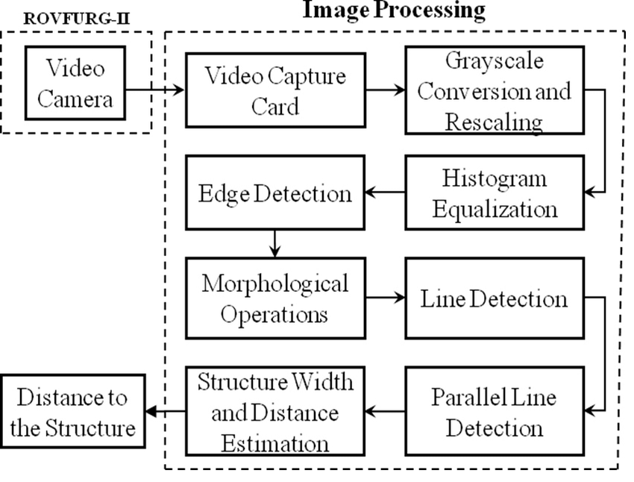

Figure 3.1: Image processing

**3.1.1** **Noise Reduction Techniques**

In the "Picture to Text" application, input images undergo preprocessing steps to enhance readability and mitigate noise. Techniques such as Gaussian blurring, median filtering, and morphological operations are applied to remove unwanted artifacts and improve the quality of the input image.

### 3.1.2 Contrast Enhancement

Contrast enhancement techniques are employed to improve the visibility of text regions within the input image. Histogram equalization, adaptive thresholding, and gamma correction are commonly used methods to adjust the contrast and improve the clarity of text regions.

## 3.2 Feature Extraction

### 3.2.1 Advanced Image Processing Algorithms

Advanced image processing algorithms are utilized to extract pertinent features from the preprocessed images. Techniques such as Scale-Invariant Feature Transform (SIFT), Histogram of Oriented Gradients (HOG), and Convolutional Neural Networks (CNNs) are employed to capture relevant visual patterns and characteristics of text regions.

### 3.2.2 Deep Learning Architectures for Feature Extraction

Deep learning architectures, including pre-trained CNN models such as VGG, ResNet, or MobileNet, are used for feature extraction. By fine-tuning these models on large datasets of text images, the application can effectively extract discriminative features that facilitate accurate text recognition.

**Chapter 4**

# CONCLUSION & RESULT

## 4.1 CONCLUSION

In conclusion, the journey of converting handwritten text into Word documents exemplifies the fusion of human ingenuity with technological advancement. Through the intricate algorithms of Optical Character Recognition (OCR) and the seamless integration of digital processing, handwritten content finds new life in the digital realm. This transformative process not only enhances accessibility and efficiency but also preserves the essence of handwritten expression.

As we navigate this landscape of innovation, it becomes evident that the conversion of handwritten text into Word documents transcends mere digitization—it represents a bridge between the tangible and the digital, the past and the future. It empowers individuals and organizations to transcend the constraints of traditional documentation, fostering collaboration, sharing, and knowledge dissemination on unprecedented scales.

## 4.2 FUTURE WORK

* Enhancing Multilingual Support: Expanding the application's capability to recognize and transcribe text in multiple languages.
* Improving Input Image Quality: Developing techniques to handle input images with varying quality to improve recognition accuracy.
* Exploring Novel Architectures: Investigating new deep learning architectures or refining existing ones to further improve recognition performance.
* Integrating User Feedback Mechanisms: Implementing features for users to provide feedback on recognition results, facilitating continuous improvement of the application.
* Extending Document Type Support: Expanding the application's functionality to recognize text from different document types, such as forms, receipts, or handwritten notes.
* Optimizing for Specific Domains: Tailoring the application for specific domains or industries, such as healthcare or finance, to address domain-specific requirements and challenges.
* Scaling for Large Datasets: Developing strategies to efficiently process and handle large volumes of image data, enabling scalability and performance optimization.
* Integration with Document Management Systems: Integrating the application with existing document management systems for seamless document digitization and workflow automation.
* Addressing Privacy and Security Concerns: Implementing robust privacy and security measures to safeguard sensitive information during the recognition process and data storage.
* 10.Exploring Edge Computing Solutions: Investigating the feasibility of deploying the application on edge computing devices to enable offline text recognition and enhance accessibility in resource-constrained environments.

## 4.3 RESULT

## 

INDIA

Figure 4.3.1: Output

# Chapter 5

**5.1** **CODING & INTERFACE**

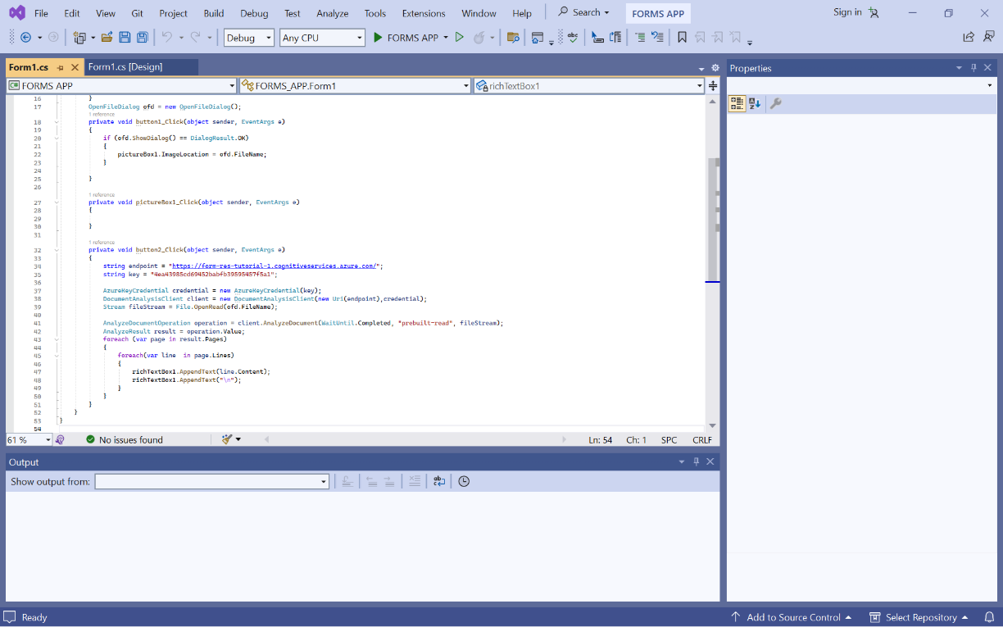

Figure 5.1: Visual studio Interface

Visual Studio provides a comprehensive Integrated Development Environment (IDE) for building various types of applications, including desktop, web, mobile, and cloud-based solutions. Leveraging its rich set of tools and features, developers can create intuitive and visually appealing user interfaces for their projects.

# 6.REFERENCES

1. Guillevic, D., & Suen, C. Y. (1998). Recognition of legal amounts on bank cheques. *Pattern Analysis and Applications, 1*(1), 28–41.
2. Wang, J., & Jean, J. (1994). Segmentation of merged characters by neural networks and shortest path. *Pattern Recognition, 27*(5), 649–658.
3. Mohamed, M., & Gader, P. (1996). Handwritten word recognition using segmentation-free hidden Markov modeling and segmentation-based dynamic programming techniques. *IEEE Transactions on Pattern Analysis and Machine Intelligence, 18*(5), 548–554.
4. Behera, R. K., Reddy, K. H. K., & Roy, D. S. (2020). A novel context migration model for fog-enabled cross-vertical IoT applications. In *International Conference on Innovative Computing and Communications* (pp. 287–295). Singapore: Springer.
5. Roy, D. S., Behera, R. K., Reddy, K. H. K., & Buyya, R. (2018). A context-aware fog enabled scheme for real-time cross-vertical IoT applications. *IEEE Internet of Things Journal, 6*(2), 2400–2412.
6. Dey, N., Ashour, A. S., Beagum, S., Pistola, D. S., Gospodinov, M., Gospodinova, Е. P., et al. (2015). Parameter optimization for local polynomial approximation based intersection confidence interval filter using genetic algorithm: an application for brain MRI image de-noising. *Journal of Imaging, 1*(1), 60–84.
7. Chatterjee, S., Hore, S., Dey, N., Chakraborty, S., & Ashour, A. S. (2017). Dengue fever classification using gene expression data: a PSO based artificial neural network approach. In *Proceedings of the 5th International Conference on Frontiers in Intelligent Computing: Theory and Applications* (pp. 331–341). Singapore: Springer.

# 7.CERTIFICATION

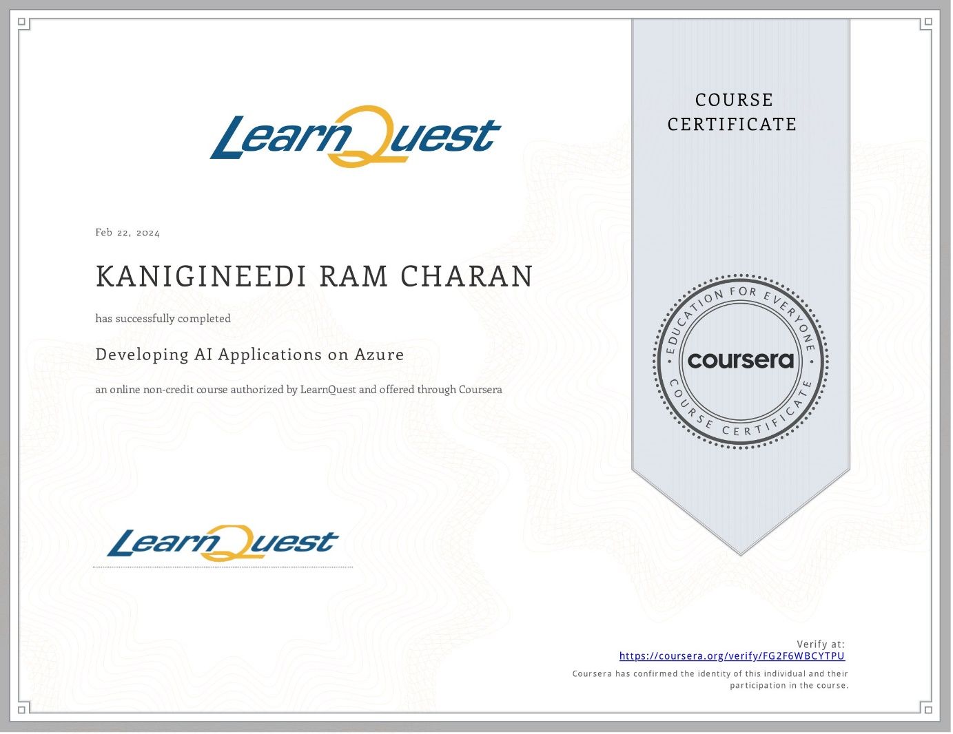

Figure 7.1 : Certificate details